Name_________________________________________________ Date: __________________________ Block: _______
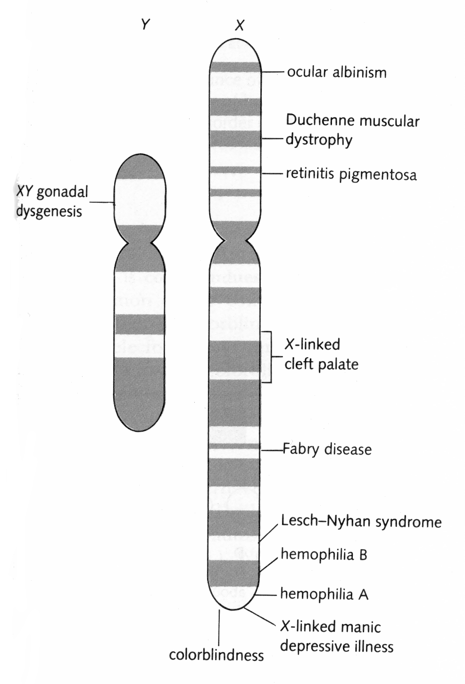
Sex-Linked Genes
In humans, the 23rd pair of chromosomes determine the sex of the individual. If the 23rd pair is XX, the individual is female; if it is XY, the individual is male.
Because these chromosomes determine sex, genes found on them are called sex-linked genes. The X chromosome is much larger than the Y and contains thousands of genes, while the stumpy little Y chromosome contains only a few genes. Because of this, there is a special pattern of inheritance for genes located on the 23rd chromosome pair.
More than 100 sex-linked genetic disorders have been mapped to the X chromosome. Because females have two X chromosomes, they have two alleles for all sex-linked genes. However, males only have one X chromosome. Since the Y chromosome is not homologous with the X chromosome, it does not contain the same genes – therefore, males only have one allele for sex-linked genes. All X-linked alleles are expressed in males, even if they are recessive.
In order for a sex-linked recessive disorder to be expressed in females, there must be two copies of the recessive allele (one on each of the X chromosomes). This means that a sex-linked genetic disorder is much more common among males than among females.
Known sex-linked disorders include hemophilia, color blindness, muscular dystrophy, SCID (severe combined immunodeficiency), and many others.
Sex-Linked Punnett Squares How-To
We will be examining inheritance patterns for hemophilia and red-green colorblindness, which are both recessive sex-linked disorders. To determine the pattern of inheritance for sex-linked traits, one can use a Punnett square. Because the inheritance of these traits depends on whether there is one or two X chromosomes present, it is necessary to draw the X and Y chromosomes. The alleles for the trait will be drawn as superscripts above the X or Y.
X^{H} | X chromosome with normal dominant allele (no hemophilia)
X^{h} | X chromosome with recessive allele for hemophilia
Y | Y chromosome does not contain the gene (no alleles present)
X^{B} | X chromosome with normal dominant allele (no colorblindness)
X^{b} | X chromosome with recessive allele for colorblindness
Y | Y chromosome does not contain the gene (no alleles present)

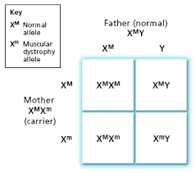
To get you started, here is a sample sex-linked Punnett square for muscular dystrophy, which is also a recessive disorder.
The mother in this example is a carrier of the disorder-- which means her genotype is heterozygous and her phenotype is normal or unaffected. The father is normal.
With these parents, there is no chance that any daughter they had would have muscular dystrophy and a 50% chance that a son would have the disorder.

Please answer the following using the letters (H/h) for hemophilia and (B/b) for colorblindness.
1. Write the genotypes for the following examples of phenotypes for colorblindness.

- Normal male _______________

- Normal female carrying no colorblindness alleles (homozygous) _________________

- Colorblind male ____________

- Normal female carrying colorblindness allele (heterozygous) ________________

- Colorblind female ____________

2. X^{B}X^{B} x X^{b}Y

- What percentage of females are affected?

- What percentage of male children are affected?

3. X^{B}X^{b} x X^{B}Y

- How many females are affected?

- What percentage of male children are affected?

- What is the probability that a colorblind woman who marries a man with normal vision will have a colorblind child?

4. A normal-sighted woman (whose father was colorblind) marries a colorblind man.

- What is the probability that they will have a colorblind daughter?

- What is the probability that they will have a colorblind son?

5. H= normal blood clotting, h= hemophilia
X^{H}X^{h} x X^{H}Y

- What is the probability that any of their children will have hemophilia?

6. A woman who is a carrier for hemophilia marries a hemophiliac man.

- What proportion of female children are hemophiliacs?

- What proportion of male children are hemophiliacs?

7. A homozygous normal woman marries a man without hemophilia.

- What is the probability that any of their children will be hemophiliacs?

8. A phenotypically normal woman has phenotypically normal parents and a brother with hemophilia. What are her chances of being a carrier?

9. Why must males inherit hemophilia or colorblindness from their mothers?

10. Why is colorblindness and hemophilia more common in males than in females?

