Osmosis Practice Sheet

Name: Date: Block:

Below are eukaryotic cells that have been placed in beakers of various concentrations.
- DRAW arrows to show which way the water would move by osmosis.
- Fill in any missing percentages (water or solute)
- Identify the type of solution (isotonic, hypertonic, or hypotonic)

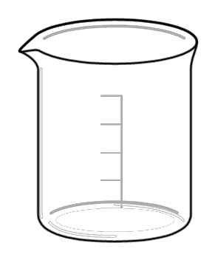

% H₂O
60 % Solute

75% H₂O
% Solute

90% H₂O
% Solute
% H₂O
15% Solute
80% H₂O
% Solute

% H₂O
75% Solute

90 % H₂O
% Solute

50 % H₂O
50% Solute

% H₂O
37% Solute

75 % H₂O
% Solute

% H₂O
15% Solute

90 % H₂O
% Solute

% H₂O
10 % Solute

% H₂O 18% Solute

90% H₂O
% Solute

50% H₂O
% Solute

90% H₂O
% Solute

% H₂O
55 % Solute

