

Group Member Names:_________________________________________ Period:
Modeling Atoms M&M Style

Background Questions:

- What is an Atom – _________________________________________________

- What three subatomic parts make an Atom – ____________________, _________________, and _________________. [Put the charge beside each answer]

- The nucleus is made of _____________ and ______________.

- What is the difference between atomic number and atomic mass?


Great!
Looks like you all have hard shells…

Let’s not melt under the Pressure.

- What do you know about Isotopes?

- Define molecule and explain how it is different from an atom?

- How many electrons are in:

        - Level 1 d. Level 4

        - Level 2

        - Level 3

Decide on your three color types, (e.g., Blue, Green, and Orange, etc.) you will need to label the color M&M you have the most of as a Neutron, then name the other two colors either Protons or Electrons.

Directions:

- WASH your Hands… Sanitize those digits!
- Model Atoms of Elements with M&M’s
- Illustrate/draw all possible elements you can make from your available candy pile.
- Identify the Element, its Symbol, the Atomic Number, Atomic Mass, and support your conclusion by identifying how many Protons, Neutrons, and
Electrons the element should have.

Helpful Hints:
- Remember that the Atomic Number is the number of Protons in an atom.
- The Mass Number is the number or Protons and Neutrons combined.
- The number of Electrons equals the number of Protons in an atom.

Example:
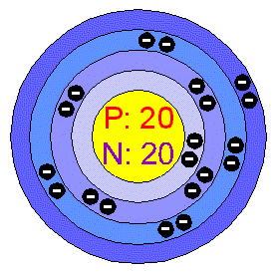
If I had 28 blue, 22 green, and 20 orange M&M’s in a LARGE pile, I could make the element Calcium.

Brief explanation:
_{Element Name} | _{Calcium}
_{Symbol} | _{Ca}
_{Atomic Number} | ₂₀
_{Atomic Mass} | _{40.08}
_{# of Protons (p+)} | ₂₀
_{# of Neutrons (n)} | _{20.08}
_{# of Electrons (e-)} | ₂₀
Because my highest color was 28, blue represents Neutrons. Green is Electrons, and Orange is Protons.
Since I only have 20 protons, which represents the Atomic Number, I know that I cannot make Scandium which has 21 protons, even though I have enough electrons and neutrons. I also know that the atomic mass of Calcium is 40, therefore if I take 40 and subtract my number of protons I now know how many neutrons I need to make Calcium.

â While I would have to construct every element decreasing in atomic number from Zinc to follow the directions, I am only demonstrating what I expect from you…
Don’t Eat the M&M’s until you have finished modeling the Possible Atoms!

Don’t Worry. Regardless of how many you could make, I am only requiring that you work on no less than 4 and UP to Six elements. If you theoretically can produce more, just list what other elements you could have made in addition to your six.

_{Element Name}
_{Symbol}
_{Atomic Number}
_{Atomic Mass}
_{# of Protons (p+)}
_{# of Neutrons (n)}
_{# of Electrons (e-)}
Brief explanation:

_{Element Name}
_{Symbol}
_{Atomic Number}
_{Atomic Mass}
_{# of Protons (p+)}
_{# of Neutrons (n)}
_{# of Electrons (e-)}
Brief explanation:

_{Element Name}
_{Symbol}
_{Atomic Number}
_{Atomic Mass}
_{# of Protons (p+)}
_{# of Neutrons (n)}
_{# of Electrons (e-)}
Brief explanation:

_{Element Name}
_{Symbol}
_{Atomic Number}
_{Atomic Mass}
_{# of Protons (p+)}
_{# of Neutrons (n)}
_{# of Electrons (e-)}
Brief explanation:

_{Element Name}
_{Symbol}
_{Atomic Number}
_{Atomic Mass}
_{# of Protons (p+)}
_{# of Neutrons (n)}
_{# of Electrons (e-)}
Brief explanation:

_{Element Name}
_{Symbol}
_{Atomic Number}
_{Atomic Mass}
_{# of Protons (p+)} | 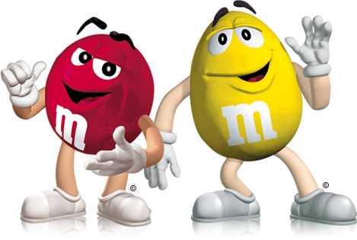  Boy, I wish I was as Good as these guys…  Yeah, I guess they aren’t too bad.  Though, they are going to eat us!
_{# of Neutrons (n)}
_{# of Electrons (e-)}
Brief explanation:



