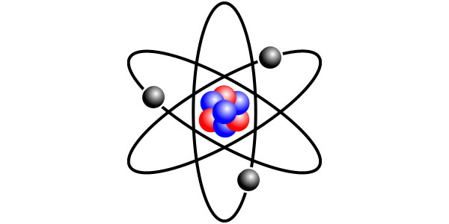
Name:
Date: Block:

Nature of the Matter Pre-Test

- Which of the following makes up a molecule of water?
  - One atom of hydrogen and one atom of oxygen
  - One atom of sodium and one atom of chlorine
  - One atom of hydrogen and two atoms of oxygen
  - Two atoms of hydrogen and one atom of oxygen

- The space surrounding the nucleus of the atom contains…?
  - Protons
  - Electrons
  - Neutrons
  - Ions

- What type of electron is available to form bonds?
  - Valance
  - Nucleus
  - Ionic
  - Covalent

- A substance with a pH of 6 is called?
  - An acid
  - A base
  - Both an acid and a base
  - Neither an acid or a base

- The three particles that make up an atom are…?
  - Protons, neutrons, and isotopes
  - Neutrons, isotopes, and electrons
  - Positives, negatives, and electrons
  - Protons, neutrons, and electrons

- Isotopes are atoms of the same element with the same number of protons and…?
  - A different number of electrons
  - A different number of molecules
  - A different number of neutrons
  - The same number of neutrons

- A covalent bond is formed as the result of…?
  - Transferring electrons
  - Sharing electrons
  - Transferring protons
  - Sharing protons

- An ionic bond is formed as the result of…?
  - The actual sharing of electrons
  - The release of energy
  - The transfer of electrons
  - Chemical energy

- The nucleus of an atom is made of…?
  - Protons and electrons
  - Electrons and neutrons
  - Protons and neutrons
  - Protons, neutrons, and electrons

- What type of ion forms when an atom loses electrons?
  - Neutral
  - Positive
  - Negative
  - Possible positive and negative

