Name______________________________________ Date: _____________________________ Block:____
Segregation
- Mendel found that alleles segregated when they formed gametes, but he wondered if they segregated ______________________________.
- Meaning, does _______________________ of alleles affect the segregation of _____________________________________________________?
  - Ex. Does the gene that determines seed shape have anything to do with seed color?
  - Will a round seed always be yellow?
Two Different Genes
- To answer these questions, Mendel performed an experiment to follow two ___________________ genes as they passed from one generation to the next.
- This experiment is called a ____________________________________________ (or two-factor cross)
Two-Trait Cross
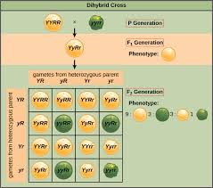
- Mendel crossed true-breeding plants that produced only round yellow peas with plants that produced only wrinkled green peas _______________________ (genotypes).
- All of the offspring were yellow and round.
  - This told us nothing we didn’t already know – that yellow and round peas were dominant over wrinkled and green.
- We still didn’t know if the two genes were _________________________________________________________.

- Mendel knew that all of the plants in the F1 generation would be _______________________ for both seed color and seed shape (RrYy)
- But he didn’t know if the dominant alleles would always stay together (RY), or if they would assort independently--- meaning that ____________________________ of alleles was possible.

- To Find out, he crossed the offspring of the F1 generation to produce the F2 generation
_______________x________________ (genotype)

How Did He Get Those Letters?
Mother (RrYy) Father (RrYy)
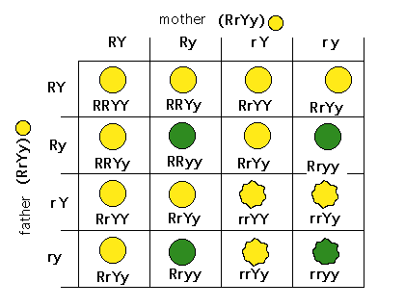
The Results:
- The F2 plants produced 556 seeds!
- Of those, 315 were yellow and round and 32 were wrinkled and green – the combinations found in the _______________________.
- BUT, 209 of the seeds had combinations of phenotypes (and therefore ______________________ of _______________) not seen in either parent!

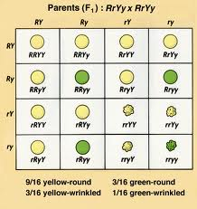
Independent Assortment:
- The appearance of NEW phenotypes in the F2 plants could only mean one thing: The genes for seed ______________ segregated independently of those for seed _______________!
- This showed that genes for a trait, like seed color, don’t _________________________________ of genes for other traits.
- This became known as the principle of independent assortment
- Independent assortment helps account for the many genetic variations seen in plants and animals!
The Golden Ratio
- Mendel found that anytime he crossed two _______________________ for two different traits, no matter the number of offspring, the ratio of phenotypes was ______________________.
- 9 – ___________________ phenotype for both traits
- 3 – dominant phenotype for one trait, recessive for the other
- 3 – reverse that
- 1- __________________ phenotype for both traits
Summary of Mendel’s Principles
- The inheritance of biological characteristics is determined by individual units known as genes. Genes are passed from parent to offspring.
- In cases in which two or more forms (_____________) of the gene for a single trait exist, some forms of the gene may be dominant and others may be recessive.
- In most sexually reproducing organisms, each adult has _________ ______________ of each gene – one from each parent. These genes are __________________________ from each other when gametes are formed.
- The alleles for _____________________ genes usually segregate independently of one another.

