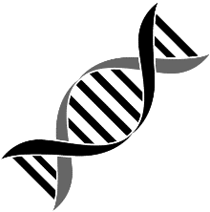
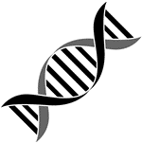
Name: Date: Block:

- DNA replication results in two DNA molecules…
  - Each with two new strands
  - One with two new strands and the other with two original strands
  - Each with one new strand and one original strand
  - Each with two original strands

- DNA is copied during a process called…?
  - Replication
  - Translation
  - Transcription
  - Transformation

- In eukaryotes, DNA…
  - Is located in the nucleus
  - Floats freely in the cytoplasm
  - Is located in the ribosomes
  - Is circular

- During DNA replication, a complementary strand of DNA is made from each original strand. Thus, if a portion of the original strand is CCTAGCT, then the new strand will be…
  - TTGCATG
  - AAGTATC
  - CCTAGCT
  - GGATCGA

- Of the four nitrogen bases in DNA, which two are purines and which two are pyrimidines?
  - Purines: adenine, thymine; pyrimidines: uracil, cytosine
  - Purines: adenine, thymine; pyrimidines: guanine, cytosine
  - Purines: adenine, guanine; pyrimidines: thymine, cytosine
  - Purines: uracil, thymine; pyrimidines: guanine, cytosine

- The enzyme responsible for adding nucleotides to the exposed DNA bases during replication are…
  - Replicases
  - DNA polymerase
  - Helicases
  - Template enzyme

- Which of the following is not true about DNA replication?
  - It must occur before a cell can divide
  - Two complementary strands are duplicated
  - The double strand unwinds and unzips while it is being duplicated
  - The new DNA molecule had two newly-made strands

