pH |  | Measure of H+ ions
Bases (pH 7-14) produce lots of |  | OH- Ions
Acids (pH 1-7) produce lots of |  | H+ Ions
Water on pH Scale |  | 7
Water has unique properties due |  | Hydrogen Bonds  (Where one oxygen is attracted to the hydrogen in a neighboring molecule of water)
Oxygen is slightly negative due electrons being more attracted to it rather than hydrogen in water. |  | Water is POLAR  Covalent
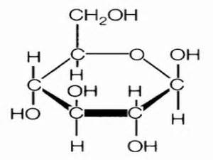 |  | Glucose  Structure
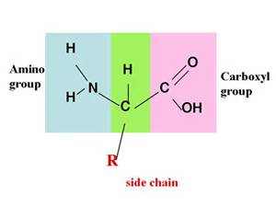 |  | Amino Acid Structure
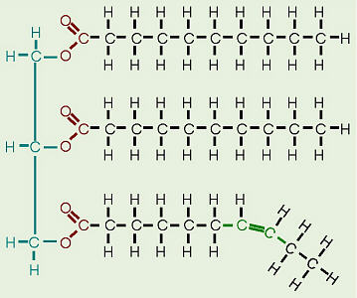 |  | Lipid  Structure
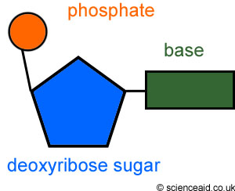 |  | Nucleotide  Structure
Methane  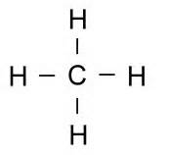 |  | Simple Hydrocarbon
Building block-subunit for Carbohydrates |  | Monosaccharide
Building block-subunit for  Protein |  | Amino Acids
Building block-subunit for  Lipids |  | Glycerol and fatty acids
Building block-subunit for  Nucleic Acids |  | Nucleotides
Carboxyl Group |  | 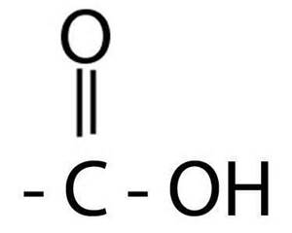
Amino group |  | 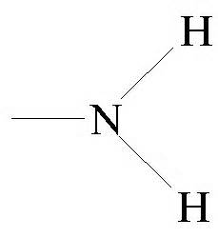
Atomic Number |  | Number of Protons
Atomic Mass |  | Protons and Neutrons
Valence Number |  | Electrons in the last shell
Substrate |  | Reactants that an enzyme will act on
Active Site |  | Site Where an Enzyme will work on the substrate
Covalent Bonds |  | Electrons are shared
Ionic |  | Electrons are transferred
Ion |  | Atoms that have lost or gained electrons
Monosaccharide |  | Glucose  Fructose  Galactose
Isomer |  | Same formula but different arrangement such a glucose and fructose
Isotope |  | Same element  Different Neutrons
Enzymes |  | Lowers activation  Energy and speeds up reactions in Organic compounds
Organic |  | Must contain the element CARBON
Two things that can destroy an enzyme |  | pH  Temperature
4 Biomolecules |  | Carbohydrates  Proteins  Lipids  Nuclei Acids
Peptide bonds |  | Bond between 2 amino acids
Dehydration  Synthesis |  | Water is removed to link to biomolecule subunits
Hydrolysis |  | Water is added to break apart two organic molecules
-OSE |  | Many sugars end in this
-ASE |  | Many enzymes end in this

