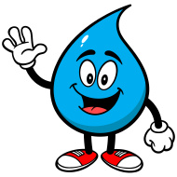
Name:
Date: Block:
Crash Course # 2: Liquid Awesome
https://www.youtube.com/watch?v=HVT3Y3_gHGg 11:16 min
- What two elements make up water?

- What is the bond called, that helps form a water molecule?

- Why is a water molecule “V” shaped, and what bonds help water become “sticky?”

- What is cohesion?

- What special property of water allows some bugs, one lizard, and perhaps one Jesus to walk on water?

- What is adhesion?

- What is capillary action?

- Why is water an amazing solvent?

- Why can ice (the solid form of water) float in water?

- What special property of water makes heating and cooling the oceans difficult?

- Why is it important to sweat?

