Name: Date: Block:
Covalent Bonds:
- Covalent bonds occur when atoms a pair of electrons.
- Occur between atoms whose outer shells are NOT full.
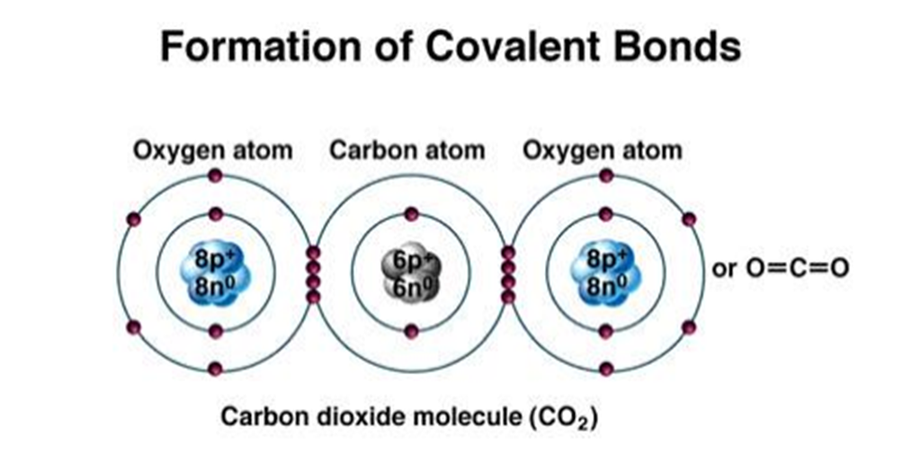
- Covalent bonds are strong chemical bonds, because the shared electrons behave as if they belong to each atom.

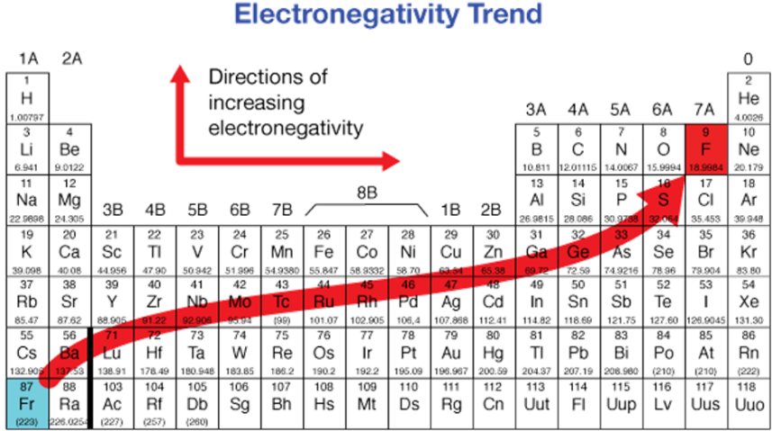
Electrons are not always evenly shared between atoms…
- Some atoms attract shared electrons more readily (easier) than do other atoms.
- The of an atom is the measure of its ability to attract electrons in a bond.
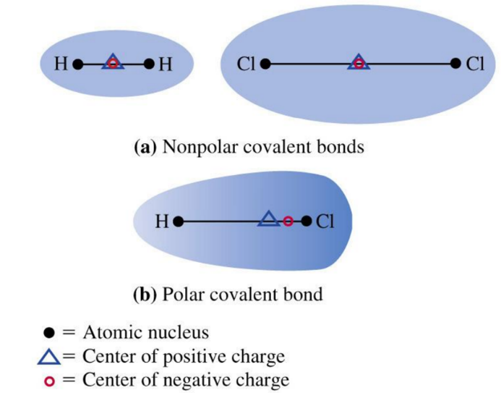
- _____________________________________________________: the distribution of electrons around the nuclei creates polarity or a difference in electric charge across the molecule.
- _____________________________________________________: a strong bond is formed between two atoms with similar electronegativities and no polarity exists.
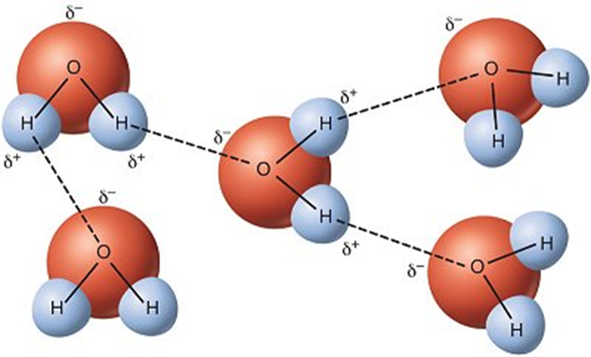
Hydrogen Bonds
- An important result of certain polar covalent bonds is the ability of one molecule to loosely associate with another molecule through a .
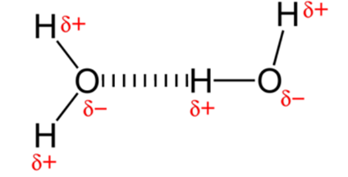
- This bond forms when a hydrogen atom from one polar molecule is attracted to an electronegative atom, in another polar molecule.
Example: is the attraction between two water molecules.

Ionic Bonds
Atoms are because they contain equal numbers of electrons and protons.
If an atom or an electron it becomes charged (ion).
An forms when an ion with a positive charge is attracted to an ion with a negative charge.
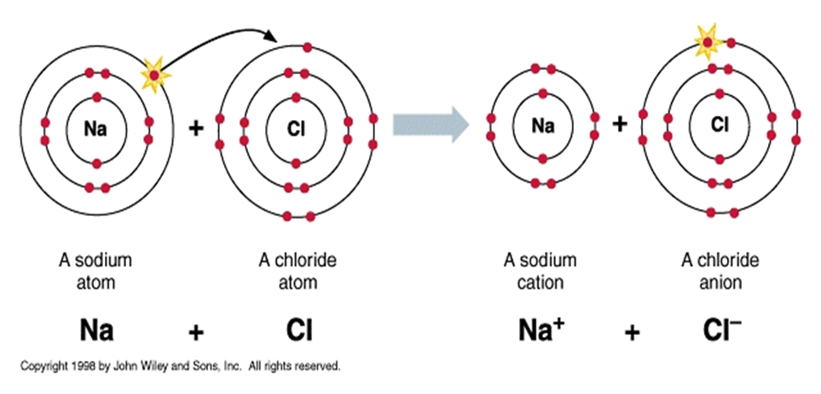

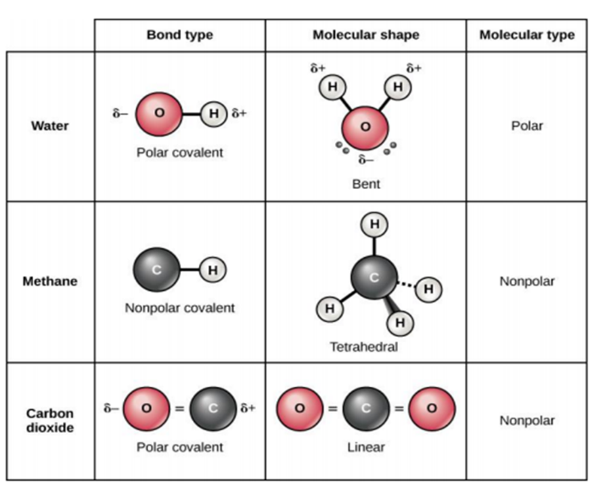
Shape of Molecules:
Molecules may change their shape
- When atoms combine, they can form various 3-D shapes, depending on their bonds.
- These shapes are flexible and rotate without breaking any of the covalent bonds.

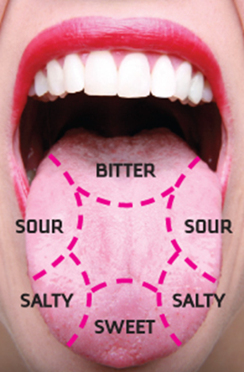
Shape Affect Life
- The 3-D flexible shape of a molecule contributes to their biological properties.
For example: Taste, food molecules interact with protein receptors on our tongues, two molecules recognize each other by their unique shape, and fit together like a key.
Common Functional Groups
- Groups of atoms with characteristic chemical features and properties attached to a molecule.
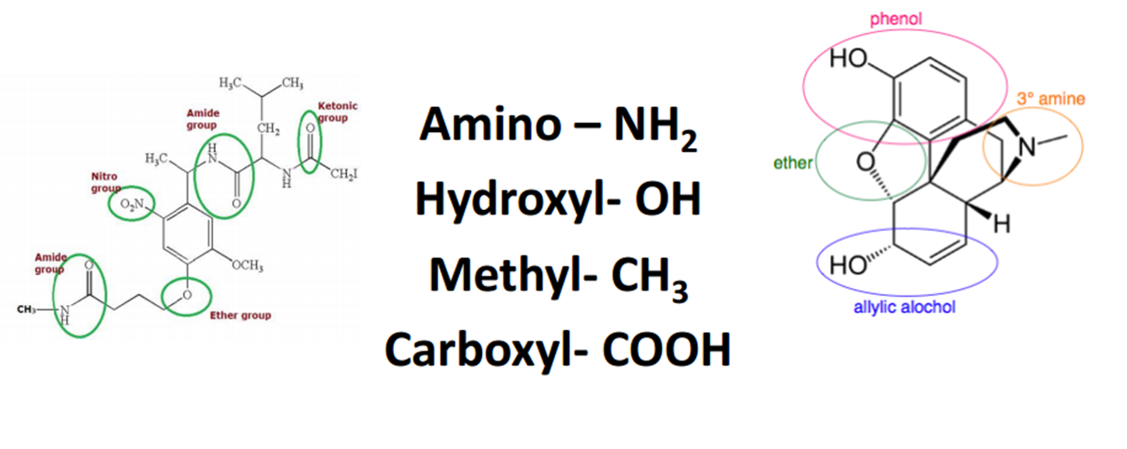
- Each functional group exhibits similar properties in all molecules it occurs in

