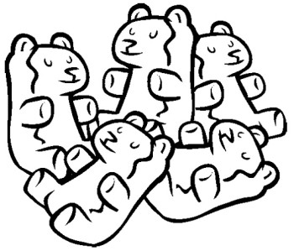
Name:
Date: Block:
Lab Score: /30 pts

Background:
Molecules are always moving. Remember that DIFFUSION is the movement of molecules from an area of high concentration (highly crowded) to an area of low concentration(less crowded). OSMOSIS is similar to DIFFUSION. OSMOSIS is the diffusion of water molecules through a selectively permeable membrane, meaning that some molecules can move through the membrane while other cannot. Cells use osmosis to move particles that it needs into and out of the cell.
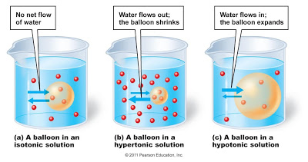

Pre-Lab Questions: (1pt each)
- What is diffusion?

- What is osmosis?

- What does selectively permeable mean?

- Prediction: How will soaking Gummy Bear candies in tap water affect the size of the candy? (Explain your prediction based on the background information).

Materials:

- Beaker | - Tap Water | - Salt
- 3 -3oz Dixie Cups | - Marker | - Digital Scale
- Ruler | - Paper Towel | - Calculator
- Plastic Fork | - 3-Gummy Bears | - Sugar

Procedure Day 1:
- Obtain a beaker, 3-Dixie Cups, 3-Gummy Bears, a ruler, and a marker.
- Fill the beaker with Tap water (or use prepared solutions).
- Label your cups with your group name. Label one “tap water” another “sugar water” and the third “salt water.”
- Pour about 1 oz of salt into the cup labeled “salt water.” (Solutions may already be prepared in advanced). This will be /3 of the cup.
- Fill each cup halfway up with tap water from the beaker.
- Measure all three Gummy Bear’s height and width in centimeters (cm) and record it in the data table below with a observable drawing.
- Using the digital scale, find all three Gummy Bear’s mass in grams and record it in the table below.
Data Table: (1 pt each)
BEFORE SOAKING IN TAP WATER  Height:  Width:  Mass:  Drawing/Description | AFTER SOAKING IN TAP WATER  Height:  Width:  Mass:  Drawing/Description
BEFORE SOAKING IN SALT WATER  Height:  Width:  Mass:  Drawing/Description | AFTER SOAKING IN SALT WATER  Height:  Width:  Mass:  Drawing/Description
BEFORE SOAKING IN SUGAR WATER  Height:  Width:  Mass:  Drawing/Description | AFTER SOAKING IN SUGAR WATER  Height:  Width:  Mass:  Drawing/Description
Procedure Day 2:
- Find your group’s cups and VERY GENTLY remove your Gummy Bears from the beakers one at a time and place them on wax paper or paper towels. Be careful not to mix the Gummy Bears up.
- Gently remove any excess moisture from your Gummy Bears.
- Using your ruler and scale, take the correct measurements to fill out the rest of your data table.
- Calculate the percent change in the size of the candy using the formulas below.
- % Change in Height: (1pt each)
After Soaking height-before soaking height X 100 = %
Before soaking height

- % Change in Width: (1 pt each)
After soaking width-before soaking width X 100 = %
Before soaking width

- % Change in Mass: (1 pt each)
After soaking mass-before soaking mass X 100 = %
Before soaking mass
Tap Water :Percent Change Salt Water: Percent Change Sugar Water: Percent Change
Height: % Height: % Height: _______%
Width: % Width: % Width: __ _______ %
Mass: % Mass: % Mass: %
Post Lab Questions: (1pt each)
- Describe what happened to your Gummy Bear after soaking it in tap water for 24-48hrs.

- What changed the most; the height, width or mass of your tap water Gummy Bear?

- Did the Gummy Bear soaked in tap water have a hypotonic, hypertonic or isotonic reaction?

- Describe what happened to your Gummy Bear after soaking it in salt water for 24-48 hours.

- What changed the most; the height, width or mass of your salt water Gummy Bear?

- Did the Gummy Bear soaked in salt water have a hypotonic, hypertonic or isotonic reaction?

- Describe what happened to your Gummy Bear after soaking in sugar water for 24-48 hours.

- What changed the most; the height, width, or mass of your sugar water Gummy Bear?

- Did the Gummy Bear soaked in sugar water have a hypotonic, hypertonic, or isotonic reaction?

Conclusion: (2pts)
- Write a PARAGRAPH in complete sentences, which explains the result of this experiment using the concept of osmosis. Think about how much swelling can occur to the Gummy Bear for it to reach a point of equilibrium or balance with the solution you soaked the Gummy Bear in. Include how your results and data support or deny your prediction. Also explain, where you may have made mistakes in the lab and how you could make the lab more accurate

