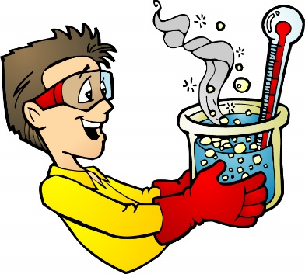
Experimental Design –Below are 2 experiment examples. Read the experiments and identify the independent variable, dependent variable, control group, and controls of each.

- Michael designs an experiment to measure the growth rate of plants with varying amounts of sunlight. He puts 5 plants under full sunlight for 8 hours a day, 5 plants under full sunlight for 4 hours a day, and 5 plants with no sunlight exposure. Each plant was potted using the same type of soil and watered each day with the same amount of liquid.
  - Independent variable

  - Dependent Variable

  - Control Group

  - Additional experimental controls

- Paige wants to test the hypothesis that eating breakfast increases student performance in school. She has 50 volunteers for the experiment, 25 that eat breakfast before coming to school and 25 that do not eat breakfast before coming to school. She measures the students’ performance by analyzing test and homework scores over a two week time period. Each student who ate breakfast, ate the same breakfast each day and all students had the exact same assignments over the 2 week period.
  - Independent variable

  - Dependent variable

  - Control group

  - Additional experimental controls

Based on the question/problem that needs to be solved, create a hypothesis and identify the experimental factors for your experiment.

- Question/Problem: Do students who study perform better in school?

  - Hypothesis: If , then
  - Independent Variable:

  - Control Group:

  - Experimental Group:

