Name: Date: Block:
Objective 1: General Chemistry Review:
- Identify subatomic particles and describe how they are arranged in atoms
- Describe the difference between ions and atoms and the importance of ions in biological processes
- Compare the types of bonding between atoms to form molecules

General Chemistry:

- Identify the 3 subatomic particles, their charges and their locations?
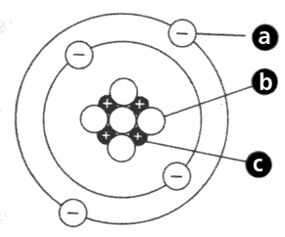
- Is a with a
charge located on the .
- Is a with a
charge, located in the
- Is a with a
charge, located in the .

- Atomic number of an element tells us the number of and the number of in that atom.
- The atomic mass identifies the subatomic particles found in the nucleus, those subatomic particles are and .
- These electrons are found in the outer most orbital of an atom and are the reason why atoms bond together. These electrons are .
- A is when electrons are shared between two or more atoms.
- A is when electrons are transferred between two or more atoms.
  - In this type of bond, atoms often lose their electrons.
- When an atom loses an electron, that atom becomes , when an atom gains an electron, that atom becomes . For example, when Sodium (Na) give its valance electron to Chlorine (Cl) to form salt (NaCl).
- The primary factor that determines of a bond between atoms is the difference in electrons to each atom.

Objective 2: Properties of Water and pH
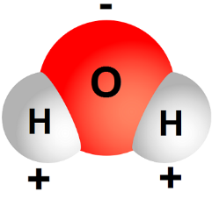
- Explain the fundamental principles of the pH scale and the consequences of having the different concentrations of hydrogen and hydroxide ions
- Define and explain the unique properties of water that are essential to living organisms
Properties of Water & pH:
- What is the shape of water?
- Water is because the atom is slightly and the atom is slightly .
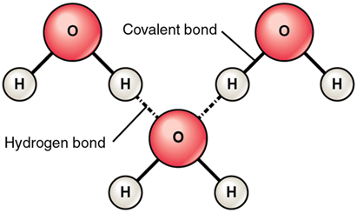
- In a water molecule, the bond between the oxygen atom and the hydrogen atom is called a . The bond between two water molecules is called a .

- The reason that water has all of its unique properties is because of its .
- The property of water that explains why certain things can dissolve easily in water is that water is a molecule.
- It is important that water is less dense as a solid, is so floats and it can .
- When two water molecules are attracted to each other, it is called , when water molecules are attracted to other things and substances it is called and is the reason water is “sticky.”
- An invisible layer that forms by the properties of adhesion and cohesion is called , and is the reason small bugs can walk on water.
- The reason why water takes a long time to boil on the stove or for a pool to heat up in the summer time is because water has a
- What does the pH scale measure?
- If is solution has a high amount of hydroxide ions (OH-) the solution is said to be what? The range is:
- If the solution has a high amount of hydrogen ions (H+) the solution is said to be what? The range is:
- This number is said to be neutral on the pH scale?

Objective 3: Organic Compounds and macromolecules
- Explain the difference between organic and inorganic compounds
- Describe the general structure and function(s), including common functional groups, of monosaccharides, disaccharides, polysaccharides, carbohydrates, fatty acids, glycerol, glycerides, lipids, amino acids, dipeptides, polypeptides, proteins, and nucleic acids

Macromolecules:
- What atom represents the word “organic?”
- Of these example, which formula is an organic compound? Circle one
  - KOH b. H₂O c. C₆H₁₂O₆ d. HCl
- The basic building blocks of macromolecules are .
- Amino acids can sometimes be difficult to identify, to best identify them look for this particular atom /functional group.
- When we eat food, the macromolecules that is used for short-term storage is called , as the macromolecule used for long-term energy storage is .

Identify the structure below. Write which macromolecule it belongs to, its monomer, and examples of each.
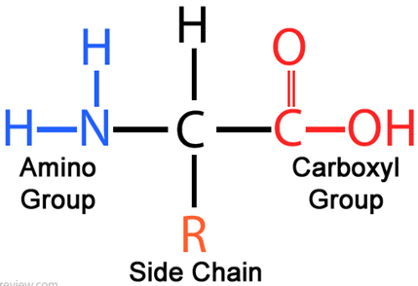
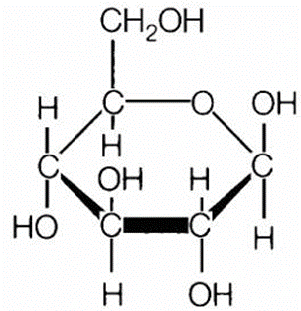

7. Macromolecule:
Monomer:
Examples:

6. Macromolecule:
Monomer:
Examples:

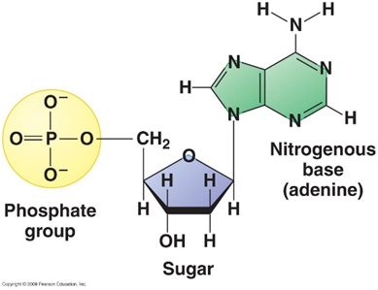
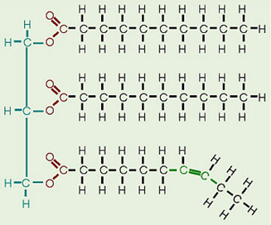

8. Macromolecule:
Monomer:
Examples:

9. Macromolecule:
Monomer:
Examples:

10. The function of Carbohydrates is to give organisms (us) .
11. The function of Proteins are required for , , and of the body’s tissues and organs.
12. The function of Lipids is to , , and store energy.
13. The function of Nucleic Acids is to carry our
14. Sugars usually end in –ose and contain the same chemical formula, which is:
15. How many amino acids can be found in nature, that are used to code for a wide variety of proteins?

Objective 4: Enzymes
  - Describe the function of enzymes, including how enzyme-substrate specificity works, in biochemical reactions

Enzymes:
- The purpose of enzymes are to act as to speed up the chemical reactions in our bodies, such as digestion, metabolism, breathing and growing.
- Enzymes speed up chemical reactions be decreasing .
- If you are lactose intolerant, it is best to add to your milk so that the enzyme can break down the lactose sugar molecules.

- Enzymes are very to the chemical reactions that it catalyzes. Meaning it binds to a particular substrate like lock and key to break substrates apart.
- An enzymes name typically ends in this suffix:
- The word means it is a substance that helps speed up chemical reactions.
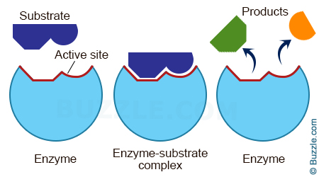
- Two things affect the rate of enzyme activity.
  - The : when temperatures increase the rate of enzyme activity increases, if the temperature is too high, enzymes will and break apart.
  - The : when pH increases or decreases, it changes the enzymes , making the substrate not fit into the enzymes active site.

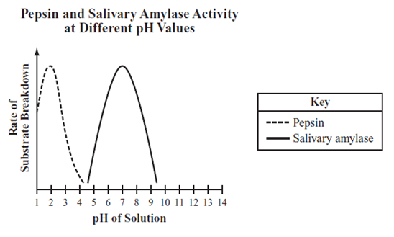

- Based on the graph above, which of the following statements best describes an effect of pH on the functioning of salivary amylase?
    - Salivary amylase functions most effectively at a pH of about 4.
    - Salivary amylase functions most effectively at a pH of about 7.
    - Salivary amylase cannot break down starch into maltose at pH values less than 7.
    - Salivary amylase breaks down protein instead of starch at pH values greater than 9.

