Name ____________________________________________
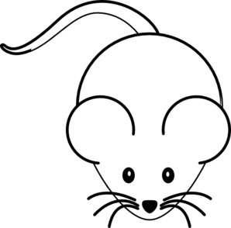
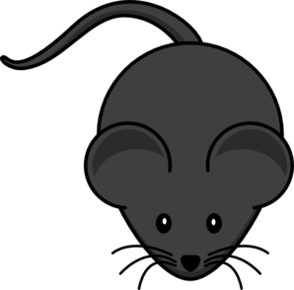
Baby Mice Bell Ringer

Drew’s pet mouse had babies. Five of the babies were black and two were white. The father mouse was black. The mother mouse was white. Drew and his friends wondered why the mice were different colors. These were their ideas:
Mikel: Baby mice inherit more traits from their fathers than their mothers.
Olivia: The baby mice got half their traits from their father and half from their mother.
Logan: Male traits are stronger than female traits.
Savannah: The black baby mice are probably male and the white baby mice are probably female.
Nathan: Parent’s traits like fur color don’t matter – nature decides what something will look like.
Megan: Blood type determines what traits babies will have.
Which friend of Drew’s do you most agree with and why?
Explain your thinking.
________________________________________________________________________________________________________________________________________________________________________________________________________________________________________________________________________________________________________________________________________________________________________________________________________________________________________________________________________________________________________________

