Name: Date: Block:
Energy & Life
- Energy is the ability to do work.
- Nearly every activity in modern society depends on one kind of energy or another.
  - Cars that run on fuel-chemical energy
  - Lights on in your home/this school-electrical energy
- Sometimes it is easy to see when energy is needed, such as needing energy to play sports.
- There are times when energy needed cannot be seen, for example when you sleep, your cells in your body are busy building proteins and amino acids
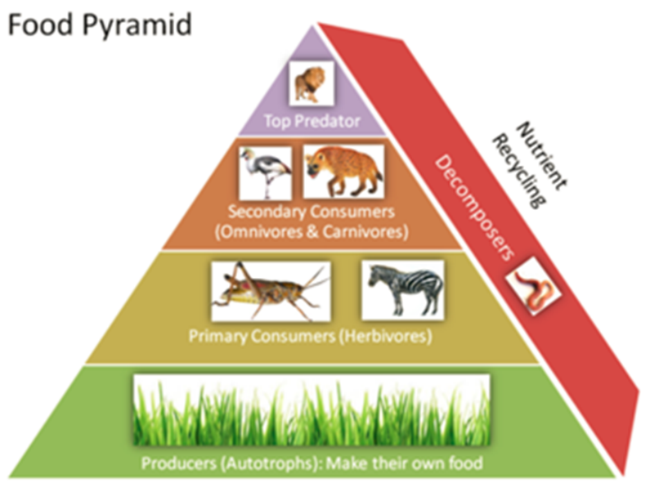
Autotrophs & Heterotrophs
- Where does the energy that living things come from? It simply comes down to food.
- Energy in most food comes from the sun.
- Plants and some other types of organisms are able to use light energy from the sun to produce food.
- Organisms such as plants, which make their own food, are called also called .
- Other organisms, such as animals, cannot use the sun’s energy directly. These organisms are known as .
  - They obtain their energy from the foods they consume.

Chemical Energy & ATP
- Energy comes in many forms such as light, heat and electricity. Energy can be stored in chemical compounds too.
- Living things use chemical fuels as well. Once of the main chemical compounds that cells use to store and release energy is or .

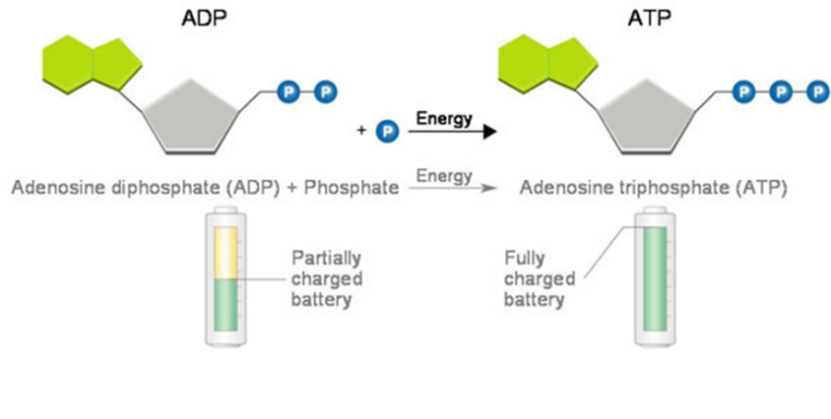
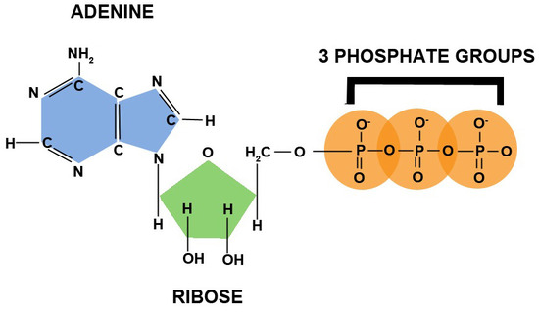
- ATP consists of a 5-carbon sugar called ribose, and three phosphate groups. The three phosphate groups are the key to ATP’s ability to store and release energy.
Storing Energy
- ________________________________________________________ is a compound that looks almost like ATP, except that it has two phosphate groups instead of three.
- When a cell has energy available, it can store small amounts of it by adding a phosphate group to ADP molecules producing ATP.
- Think of it as ATP being a fully charged battery, ready to power the machinery of a cell.
Releasing Energy
- How is the energy stored in ATP released? Simply by breaking the chemical bond between the second and third phosphates, energy is released.
- Because a cell can subtract the third phosphate group, it can release energy when needed. ATP has enough energy to power a variety of cellular activities, including active transport across cell membranes, protein synthesis, and muscle contractions.
- The characteristics of ATP make it exceptionally useful as the basic energy source of all cells.
Using Biochemical Energy
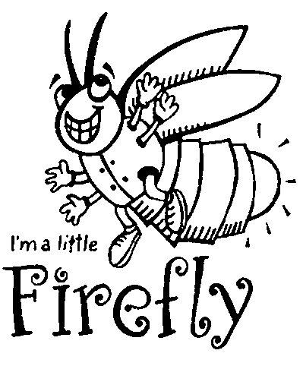
- Energy from ATP powers other important events in the cell such as protein synthesis and nucleic acids and responses to chemical signals at the cell surface.
- The energy from ATP can even be used to produce light, for example, the light from a firefly used ATP.
- You might think ATP is so useful that it could power cells all day, however cells contain small amounts of ATP, enough to last them a few seconds of activity.
- ATP is great for transferring energy, it is not great for storing energy, which is why cells keep only a small amount on hand and use it when needed. Cells can regenerate ATP from ADP in foods like glucose.

Photosynthesis: An Overview

Investigating Photosynthesis
- The key cellular process identified with energy production is
  - Which is the process of plants using the energy of the sunlight to convert water and carbon dioxide into high-energy carbohydrates-sugars and starches- and oxygen (a waste product.
- Break down the word:
  - Photo- :
  - -synthesis:
  - Therefore: using light to put things together.
- Investigating photosynthesis came from a simple questions centuries ago…
  - When a tiny seed grows into a large tree with a large mass, where does the tree’s increase in mass come from?
- The soil, the air, from water?
Contributing Scientist of Photosynthesis:

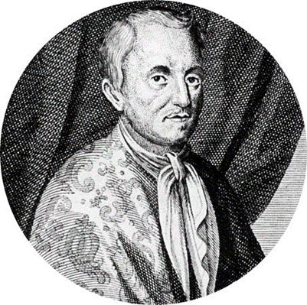
- __________________________________________ 1600 a Belgian physician devised an experiment to find out if plants grew by taking material out of the soil.
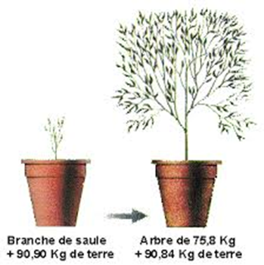
- He weighed a pot of soil, added a seedling and watered it regularly for 5 years.
- The seedling grew into a small tree and gained 75kg, the mass of the soil however was unchanged.
- He concluded that the most of the gain in mass had to come from the water because that was the only thing he had added.
- This experiment contributed to the “hydrate” or water portion of carbohydrate produced by photosynthesis.
- But where does the “carbo” part come from. van Helmont had not realized yet that carbon dioxide was a major contributor to the mass of his tree.

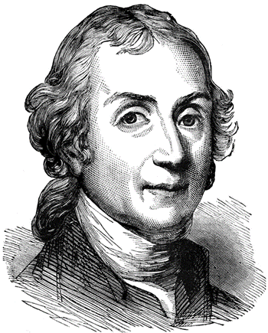
- More than 100 yrs after van Helmont, and English minister __________________________________________performed an experiment that would give a further insight to photosynthesis.
- He took a candle, placed a glass jar over it, and watched as the flame gradually died out.
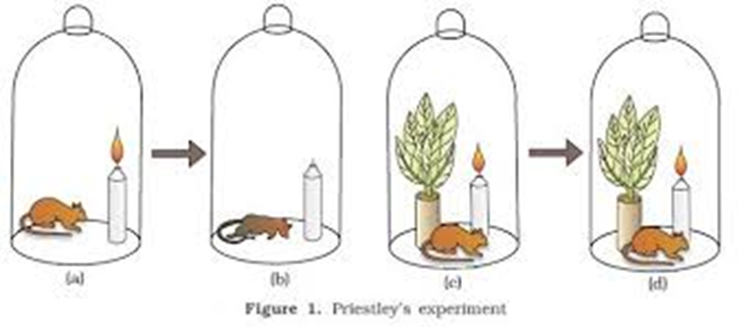
- Something in the air was necessary for the candle flame to remain burning. When that substance was used up, the candle went out. That substance was oxygen.
- Priestley then found that if he placed a live sprig of mint under the jar and allowed a few days to pass, the candle would be relit and would remain lighted for a while.

- The mint plant produced the substance required for burning. In other words…it released oxygen! YAY!

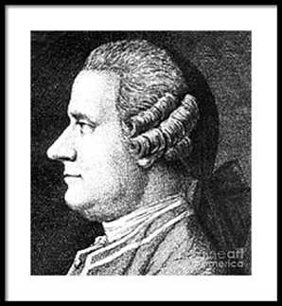
- ______________________________________________ ( a Dutch scientist) later showed that the effect observed by Priestley occurred only when the plant was exposed to light.
- The results showed that light is necessary for plants to produce oxygen.
- The experiments performed by van Helmont, Priestley, and Ingenhousz let to work by other scientist who finally discovered that in the presence of light, plants transform carbon dioxide and water into carbohydrates, and they also release oxygen.
- He worked with aquatic plants and realized that in the presence of sunlight, the plants made bubbles.
The Photosynthesis Equation
*It is crucial that you know this equation. Both the products and reactants.
- Because photosynthesis usually produces 6-carbon sugars (C₆H₁₂O₆) as the final product, the overall equation for photosynthesis is as follows: Fill the Equation in!
Light

Chlorophyll

- Photosynthesis uses the energy of sunlight to convert water and carbon dioxide into high-energy sugars and oxygen.
- Plants then use the sugars to produce complex carbohydrates such as starches. Plants obtain CO2 from the air or water in which they grow.
Light and Pigment
- We know plants use low energy raw materials to make high-energy sugars, but how?
- In addition to water and carbon dioxide, photosynthesis requires light and
__________________________, a molecule in chloroplast.
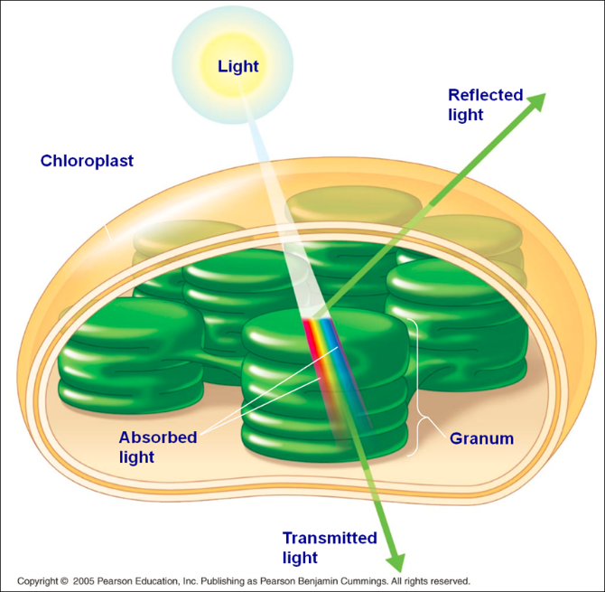
- Energy from the sun travels to Earth in the form of light. Sunlight, which your eyes perceive as “white” light, is actually a mixture of different wavelengths of light.
- Many of these wavelengths are visible to your eyes and make up what is known as the visible spectrum.
- Your eyes see the different wavelengths of the visible spectrum as different colors.
Pigments
- A is a substance that absorbs certain wavelengths of light and reflects others.
- Light is absorbed by plants through pigments.
- These pigments are located in the chloroplast.
Types of Pigments
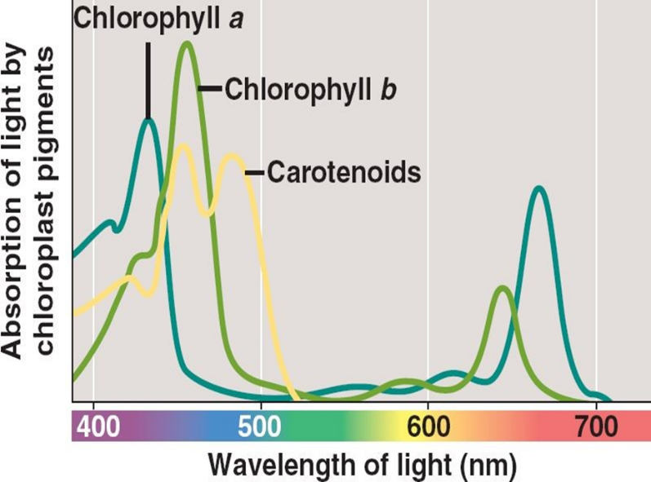
- Plants contain ________________________________, a green pigment that absorb light energy used to start photosynthesis.
- Chlorophyll absorbs blue and red lights and reflects yellow and green, which make plants appear green.
- There are two types of chlorophyll:
  - ____________________________________-appears bright green
  - ____________________________________-appears olive green.

How to Read an Absorption Spectra
- Where the curve peaks: much of the light at that wavelength is absorbed (least visible).
- Where the curve dips: much of the light at that wavelength is reflected (most visible).
- Green light is reflected by leaves which is why they appear green.
- When chlorophyll absorbs light, much of that energy is transferred directly to electrons in the chlorophyll molecule, raising the energy levels of the electrons. These high energy electrons make photosynthesis work.
