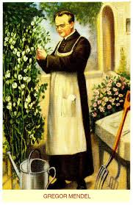
Name________________________________
Gregor Mendel
- Considered the father of
- Genetics – the study of
- Austrian Monk born 1822
- Worked primarily with pea plants
Why Did He Use Pea Plants?
- _____________________ _____________________________ Mendel was able to isolate male and female gametes.
- ___________________: It was easy to identify traits (characteristics that are inherited)
- ___________ ______________: Pea plants were able to be grown quickly.
The Pea Plants
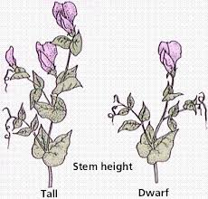
- _____________________________- the joining of male and female sex cells to produce a new cell (embryo)
- Pea plants are normally self-pollinating
- _____________________________ - sperm cells in pollen fertilize egg cells on the same flower.
- The pea plants that Mendel used were true-breeding, meaning that if they were allowed to self-pollinate, they would produce offspring _________________________________________________________________________.
Ex. All tall plants produced only tall plants, all short plants produced only short plants.

- Mendel wanted to produce seeds by joining the sex cells of two different plants.
- To do this, he had to prevent the plant from ___________________________________
- He accomplished this by cutting the pollen-bearing male parts off of one flower, and then dusting the pollen from another plant onto the flower. This was called ______________________________________.

- Cross-Pollination produces seeds that have two different plants as parents.
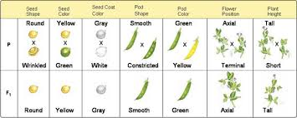
- This made it possible for Mendel to cross-breed plants with different characteristics, and then study the results!
- Mendel studied 7 different traits of pea plants
- He would cross plants that were true-breeding for two _________________________________ and observe their offspring.

Important Vocabulary!

Trait- _________________________________________________________________________
_____________________________________________________________________________.
Ex. Seed color or plant height.

Hybrid- _______________________________________________________________________
_____________________________________________________________________________.
Ex. Crossing a pea plant with purple flowers with a plant that has white flowers.

Mendel concluded that biological inheritance is determined by factors that are passed from one generation to the next. Today, scientists call the chemical factors that determine traits genes.
Gene- ________________________________________________________________________
_____________________________________________________________________________.

Allele- ________________________________________________________________________
_____________________________________________________________________________.
Ex. The gene for pea plant height comes in two forms: tall and short. Allele for tallness or allele for shortness.
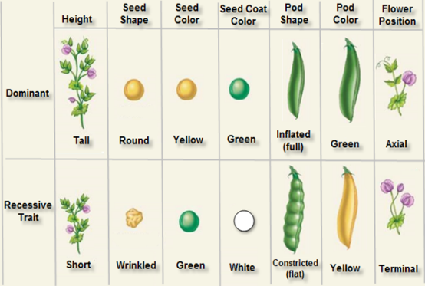
The Principle of Dominance
- Some alleles are dominant and some are recessive.
- An organism with a ________________________ allele for a trait will always exhibit that trait.
- An organism with a ________________________ allele for a trait will ONLY exhibit that trait when the dominant allele for that trait is not present.

- Since the allele for tallness was dominant and the allele for shortness was recessive, when Mendel crossed a true-breeding tall plant with a true-breeding short plant, all of the offspring would be _______________.
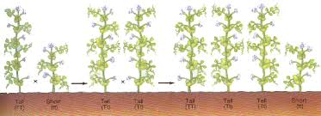
Laws of Segregation
Mendel wondered: Had the recessive alleles (shortness) disappeared? Or were they still present in the F1 plants somewhere?

To answer this question, he allowed the F1 hybrid plants to ____________________________ to form another generation of offspring (F2).

The results of the F1 cross were remarkable! The recessive trait of shortness had reappeared in the F2 generation!
- Roughly _______________ of the offspring in the F2 generation had the __________________ trait. Mendel repeated the experiment with the other traits, and the same patterns held true!

Why did This Happen? Segregation Explained!

- The answer is in meiosis!

- During gamete formation, alleles segregate from each other when the __________________ _______________________ separate in ______________________ of Meiosis.

- Remember that Meiosis produces ___________________ cells – leaving the gametes with only a ____________________ copy of each gene.

- The alleles are paired up again – randomly – when the egg and sperm unite during fertilization!

