Name ______________________________________

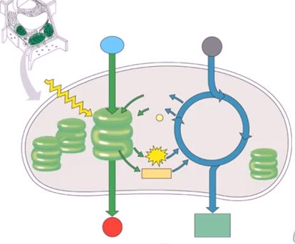
Please utilize the words below to complete the overview of photosynthesis

Word Bank:
LDR, Calvin Cycle, Thylakoid, Stroma, O₂ (Oxygen), CO₂, light, C₆H₁₂O₆ (glucose), NADP+, NADPH, ATP, ADP, Water

