DNA Exit Slip
Discovery & Structure

Name: Date: Block:

- What did Griffith observe when he injected into mice a mixture of heat-killed disease causing bacteria and live harmless bacteria?
  - The disease-causing bacteria changed into harmless bacteria
  - The mice developed pneumonia
  - The harmless bacteria died
  - The mice were unaffected

- Avery’s experiments showed that bacteria are transformed by…?
  - RNA
  - DNA
  - Proteins
  - Carbohydrates

- Using radioactive tracers to determine the interactions of bacteriophages and their host bacteria, Hershey and Chase demonstrated without question that…?
  - Genes are composed of protein molecules
  - DNA and proteins are actually the same molecule located in different parts of the cell
  - Bacteria inject their DNA into the cytoplasm of bacteriophages
  - DNA is a molecule that stores genetic information for cells

- What was the conclusion of the Hershey-Chase experiment?
  - DNA from bacteriophage entered the bacteria
  - DNA from bacteriophage became bacterial DNA
  - Protein from the bacteriophage entered the bacteria
  - Protein from the bacteriophage became bacterial DNA

- Watson and Crick built models that demonstrated that…?
  - DNA & RNA have the same structure
  - DNA is made of two strands that twist into a double helix
  - Guanine forms hydrogen bonds with adenine
  - Thymine forms hydrogen bonds with cytosine.

- What combines with a sugar and phosphate group to form a nucleotide?
  - Amino acids
  - Deoxyribose
  - Glycerol
  - Nitrogenous base

- Molecules of DNA are composed of long chains of …?
  - Amino acids
  - Fatty acids
  - Nucleotides
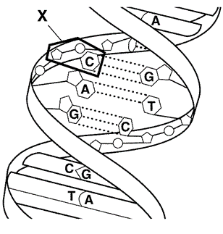
  - Monosaccharides

- The figure to the right is a structure of what?
  - DNA molecule
  - Amino acid
  - RNA molecule
  - Protein

- Which of the following is a nucleotide found in DNA?
  - Ribose + phosphate group + thymine
  - Ribose + phosphate group + uracil
  - Deoxyribose + phosphate group + uracil
  - Deoxyribose + phosphate group + cytosine

- Because of base pairing in DNA, the percentage of…
  - Adenine molecules in DNA is about equal to the percentage of guanine molecules
  - Adenine is about equal to thymine
  - Purines in DNA is much greater than the percentage of pyrimidines
  - Cytosine molecules in DNA is much greater than the percentage of guanine molecules.

