Objective 1: Explain the interaction between pigments, absorption of light, and reflection of light.

- What are pigments?

- List below the 4 most common pigments found in plants?

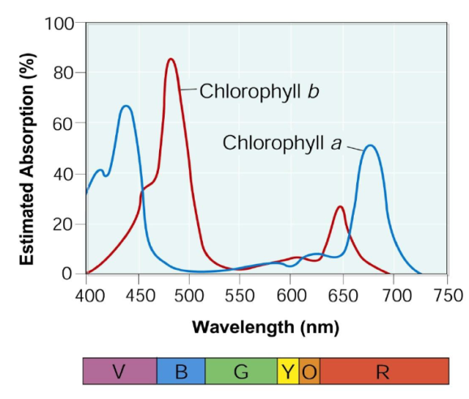
According to the absorption spectrum below, answer the following questions:
- What is the most visible color of pigment?

- What is the least visible color of pigment?

- What percentage of blue pigment is being absorbed?

- What percentage of blue is being reflected?

- If plants were only exposed to green light, what would be the most likely result?

- Why are leaves flat on a plant or tree?

- What are the tiny pores on the surface of a plant called? Why are they so important to plants?
Objective 2: Describe the light-dependent and light-independent reaction on photosynthesis. Relate the products of the light-independent reactions to the products of the light-independent reactions.

- Write the equation for photosynthesis below. Indicate which side is the reactants and which side are the products.

- In what organelle does photosynthesis take place?

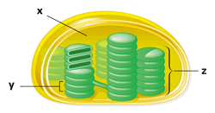
- In which structure (indicate the letter) do light-dependent reactions occur. What is this structure called?

- In what structure does the Calvin Cycle occur? What is the gel-like substance called?

- What is the purpose of water in photosynthesis?

- Photosynthesis is the ability to convert energy from the sun into chemical energy used by plants. Much of this chemical energy is stored as?

- Light-independent reactions make what for the cell?

- List and describe the sequence of events of photosynthesis.

- What are the 3-4 factors that influence the rate of photosynthesis? (we learned these as limiting factors.

KNOW that ATP stands for adenosine tri-phosphate: The P stands for PHOSPHATE
Objective 3: Identify the cellular sites of and follow the major pathway of anaerobic and aerobic respiration, compare reactants and products for each process, and account for how aerobic respiration produces more ATP per monosaccharide. Explain how photosynthetic organisms use the processes of photosynthesis and respiration.

- What is Cellular Respiration?

- What organelle is responsible for cellular respiration?

- In the space provided, write the equation for photosynthesis.

- What are the three steps in order of cellular respiration in the presence of oxygen, and how many ATP are produced in each step?

- Which step the cellular respiration produces the most ATP?

- If oxygen is NOT present, glycolysis then goes into what?

- What are the two types of fermentation? and

- Be sure to study your Cellular Respiration Notes, Bell Ringers and Exit Slips! GOOD LUCK!

