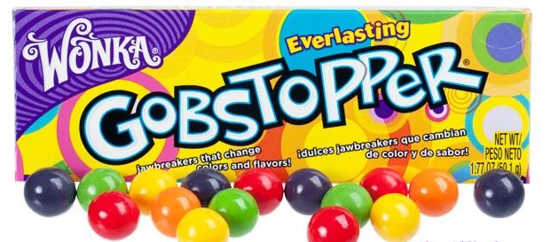
The
Lab

Question:

What will 4 gobstoppers in a plate of water look like after 10 minutes?

Hypothesis:
If four gobstoppers are placed on a plate of water for 10 minutes then because

Materials:
- Styrofoam/clear plastic plate
- Water in a small beaker
- 4 different color Gobstoppers™
- Colored Pencils or Crayons
Procedure:
- Place the plate flat on your desk and fill it almost to the top with water.
- Equally space 4 different color Gobstoppers on the plate as illustrated.
- Observe and record what you see every minute for 10 minutes. Be sure to observe from the top and the sides. At the end of 10 minutes, make a sketch of your observations.
Conclusion:
- What it looked like at the beginning and at the end of 10 minutes:
After
Before

- How would you test your hypothesis? Design an experiment that could support or rule out your hypothesis.

- Whenever possible, a hypothesis should be tested by an experiment in which only one variable is changed at a time. All other variables should be kept unchanged, or controlled. This is called a controlled experiment. The variable that is being deliberately changed is called the independent variable. In your experiment, what is the independent variable? .

- The variable that you want to observe is called the dependent variable. In your experiment, which is the dependent variable? .

